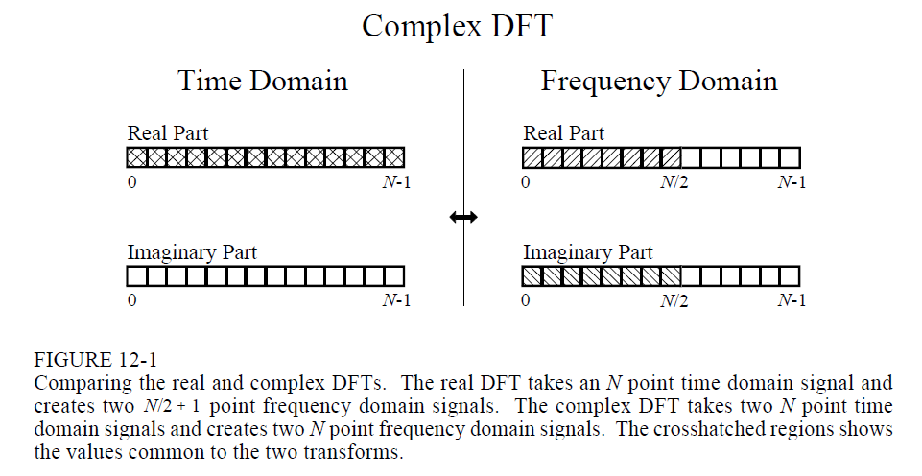

Example of Interlaced Decomposition:

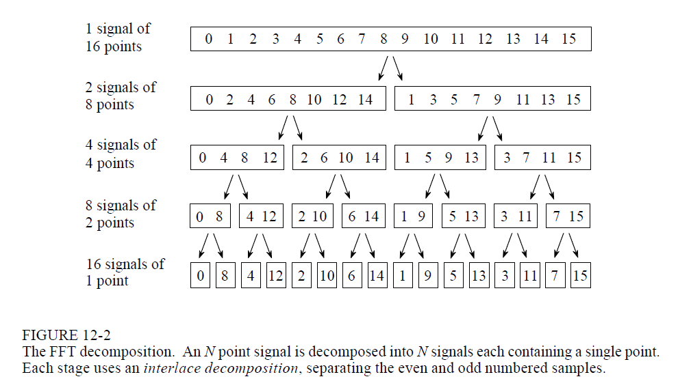

Interlaced decomposition for each stage can be thought of as bit reversal, equivalently. So this process accomplishes the same as in Figure 12-2, and is how we would have to approach it in the context of the program. Reverse binary indexing would be a method which is an extension of this; assign a normal ascending index to left, and then there is a transformed equivalent on the right side.

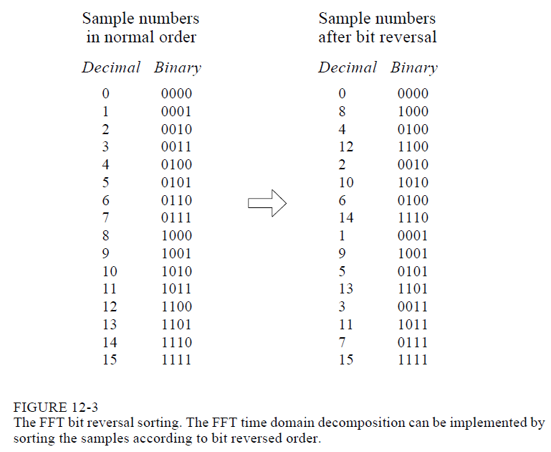

General Flow Diagram (which shows an example of the standard 3 for loop)

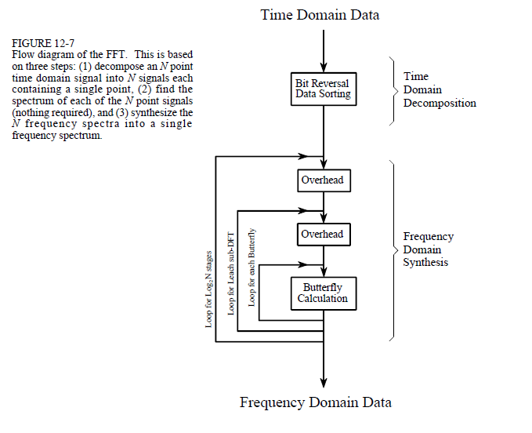

Working with the Complex DFT versus the Real DFT:

Real: 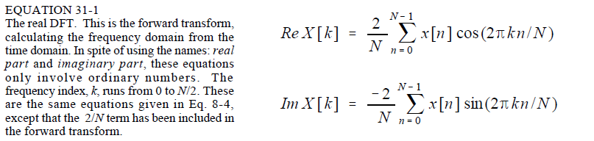

Complex:

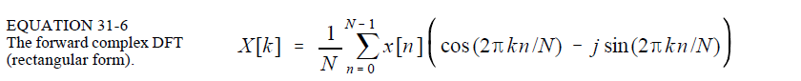

The difference is in 1. The scaling factor, 2. It’s an extension of the rectangular coordinates using Euler’s formula. [www.dspguide.com/CH31.pdf](http://www.dspguide.com/CH31.pdf) has a list that includes five differences between the real and complex dft, I didn’t know which ones were most significant to include.

From Table at End of Document:

